Healthy/Unhealthy Assignment
Student’s Name
Institution Affiliation

Healthy/Unhealthy Assignment
ITEM | HEALTHY/UNHEALTHY
- Peanut Butter  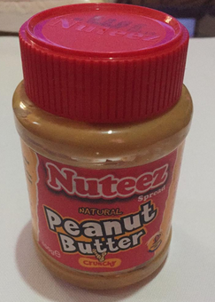 | Healthy- The primary component is roasted peanuts. The peanut butter provides a healthy source of proteins, rich in fibre with the crunchy nuts, an energy booster, helps with weight loss and has healthy fats.
- Honey  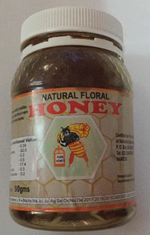 | Healthy – Natural occurring honey is a healthy option offering a high nutritional value of estimated carbohydrates 82.0, proteins 0.39 and organic acids 0.3. Moreover, natural honey does not have any preservative.
- Porridge Flour  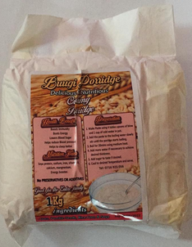 | Healthy: Nutritional facts on the creamy porridge have soya protein, vitamin A, magnesium, calcium, and Iron. These nutrients are important to aid in boosting energy, boosting immunity, helps sleep better and reduced blood pressure.
- White Rice  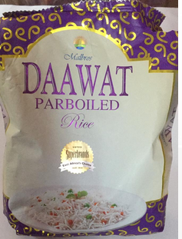 | Unhealthy: white rice is considered unhealthy given its low fiber content, which makes one to eat more portions in comparison to brown rice with more fibre. For instance the fibre on the white rice per 100g serving is 0.4g in comparison to brown rice fibre per 100g serving 15.g.
- Instant Indomie  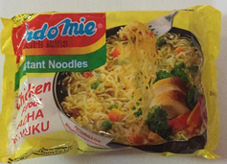 | Unhealthy: Despite offering energy of about 459 Kcal/Cal per 100g per serving it is not a healthy option. This is attributed to the high number of chemical ingredients added such as sodium, artificial chicken flavour, riboflavin (colouring) among others.
- Corn flour  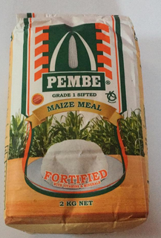 | Healthy: the maize flour is fortified with health benefits such as Vitamin A for boosting healthy bones and strengthening body immune system. B Vitamins for better brain development, promotion of healthy digestive and nervous systems. Folic acid assists in building new cells and better foetus development. Iron facilitating production of red blood cells and Zinc which boosts immune and a powerful antioxidant.
- Whole Milk  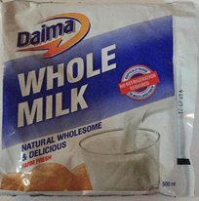 | Healthy- whole milk is important as it is packed with nutrients such as phosphorus, calcium and potassium. These nutrients are important to prevent bone fractures and help one to maintain healthy weight.
- Whole Meal Brown bread  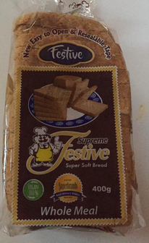 | Healthy: Whole meal brown bread not only provides an individual with the needed carbohydrates for the day but also is packed with fibres in comparison to white bread which has minimal fibres if any present.
- Milo  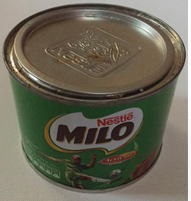 | Healthy: ingredients of malt extracts, skimmed milk and palm oil as the main ingredients. This product provided the needed energy for the day of an estimated 412K/Cal per 100g with extensive vitamins Bs, Vitamin C and Vitamin D. Also there are traces of both Calcium and Phosphorous.
- Spaghetti  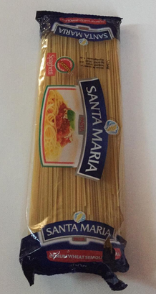 | Healthy: this pasta provides energy K/cal of about 358Kj. The pasta provides an individual with long lasting energy which is released gradually during the day and thus one does not have to eat junk foods. Furthermore, the past has minimal fat and no cholesterol.

